**Attraction Type Moving Iron (MI) Instrument - Construction, Working & Torque Equation**

The moving iron type instruments are one of the types of measuring instruments used for measuring voltage or current. These instruments use a movable piece of iron placed in the magnetic field that deflects the pointer over the scale and hence named moving iron instrument. There are two types of moving iron (MI) instruments. They are, attraction type and repulsion type moving iron instruments. In this article let us learn about attraction type moving iron instrument.

The working principle of attraction type moving iron instrument is based on magnetic attraction, which attracts an iron piece when placed near a magnet field. Here, the magnet field will be produced by an electromagnet.

Construction of Attraction Type Moving Iron Instrument :

It consists of a fixed coil that is flat with a narrow opening in it. A moving iron that is made of soft iron is mounted on a spindle. The coils are wound with a number of turns that depend upon the range of the instrument. The pointer is mounted on a spindle which consists of a graduated scale for showing the deflection. The construction of attraction type moving iron is shown below.

[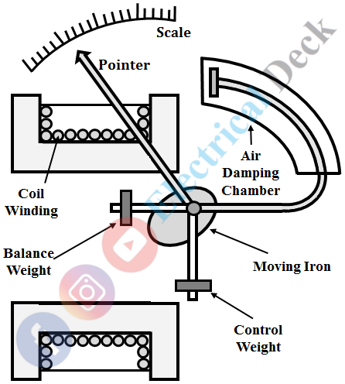](https://1.bp.blogspot.com/-2qojRpNBf7s/YIG3R4AcwrI/AAAAAAAADK0/qQc4Gal3GiIOQ7h8CSJ_40DtoyVpGUeGwCLcBGAsYHQ/s0/MI%2B-%2Battraction%2Btye%2Bmoving%2Biron%2Binstrument%2B-%2B1.png)

The controlling torque is provided by the springs or if the instrument is vertically operated gravity control can also be employed. This instrument uses air friction damping to damp out oscillations which consist of a movable piston made of aluminum placed in an air chamber.

Since the operating magnetic field produced by the coil winding is not much strong, the eddy current damping which uses permanent magnets can distort the main field. Thus eddy current damping cannot be used and fluid friction damping is not much preferred. The moving iron is made of sheet metal for obtaining a uniform scale.

Working of Attraction Type Moving Iron Instrument :

Whenever coil winding is connected across the supply to be measured, it setups a magnetic field. The intensity of the magnetic field is higher inside the coil compared to the intensity of the outside, and hence low reluctance exists inside the coil. As the moving iron tries to occupy the low reluctance position, it is moved and gets attracted to the fixed coil. As the iron piece moves, the pointer also moves to show the deflection. The instrument attains the equilibrium position when controlling torque balances the deflecting torque.

[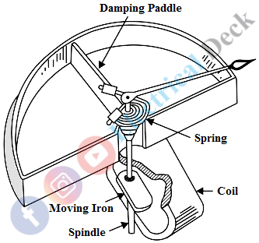](https://1.bp.blogspot.com/-5GSZBhALZqU/YIG3lG-FtUI/AAAAAAAADK8/SsjDylgznwk9oebf5jShN4gy0psAHCp-ACLcBGAsYHQ/s0/MI%2B-%2Battraction%2Btye%2Bmoving%2Biron%2Binstrument%2B-%2B2.png)

Torque Equation of Moving Iron Instruments :

Let,

* Td = Deflection torque in N-m
* θ = Deflection in radians
* L = Inductance in Henry
* I = Initial current
* dI = Change in initial current
* dL = Change in inductance
* dθ = Change in deflection

The voltage drop across the ammeter is given by,

[Attraction Type Moving Iron (MI) Instrument](https://1.bp.blogspot.com/-icxnuTF410A/YIG4BC0BxmI/AAAAAAAADLE/KPv7rP57BRoghab0b1SEELpRjYeotV-KACLcBGAsYHQ/s0/MI%2B-%2Battraction%2Btye%2Bmoving%2Biron%2Binstrument%2B-%2B3.PNG)

The energy consumed by the meter,

[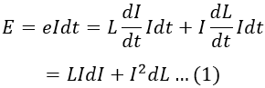](https://1.bp.blogspot.com/-Hk6DoWGSQbo/YIG-lLUD_aI/AAAAAAAADLg/EUw5yBdpY78iEOya_uSW6xROvTMLCaQ2QCLcBGAsYHQ/s0/MI%2B-%2Battraction%2Btye%2Bmoving%2Biron%2Binstrument%2B-%2B4.PNG)

     For a small increment in current (dI), the deflection is increased by dθ. We know that the energy stored by the inductance of the meter = 1/2 LI2. Therefore, new energy storage due to increment in current,

*= 1/2 (L + dL)(I + dI)2*

The change in stored energy is,

[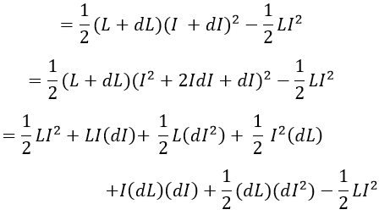](https://1.bp.blogspot.com/-pWzTzuWaR-Q/YIG4KzUrrjI/AAAAAAAADLM/CXtSW1iV0ugSMocuVMIbYN9I-vVoU_DFwCLcBGAsYHQ/s0/MI%2B-%2Battraction%2Btye%2Bmoving%2Biron%2Binstrument%2B-%2B5.PNG)

Neglecting the second and third order differential terms, we get change in stored energy as,

*= LIdI + 1/2 I2 dL ...(2)*

We have work done = Td × dθ = Td dθ ...(3)

From the law of conservation of energy, we have,

*Energy consumed = Work done + Change in stored energy*

Substituting equations 1, 2, and 3 in 4, we get,

[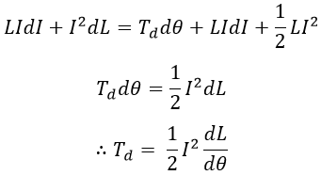](https://1.bp.blogspot.com/-t4I3GrgQI6E/YIG4PJJS8JI/AAAAAAAADLQ/bqHgfd82klEy18-S5xzqWXDEKkU0dhqywCLcBGAsYHQ/s0/MI%2B-%2Battraction%2Btye%2Bmoving%2Biron%2Binstrument%2B-%2B6.PNG)

     From the above, we can say deflecting torque produced is proportional to the square of the current. For ac measurement, the readings obtained will be the RMS value of the current or voltage. Due to square law response of the instrument, the scale of moving iron instruments is not uniform.

Advantages of Attraction Type MI Instruments :

* The instruments can be used for measuring both dc and ac quantities.
* Simple in contruction.
* Since the winding coil is kept stationary, these instruments are robust and reliable.
* As attraction type instruments have lower inductance, the measurement can be done over a wide range of frequencies.
* A shunt can be connected in parallel with the basic instrument in order to measure heavy currents.

Disadvantages of Attraction Type MI Instruments :

* These are not suitable for economical production in manufacturing.
* The power consumption is higher for a low voltage range.
* Accuracy in the readings cannot be obtained due to the non-uniform scale.

Applications of Attraction Type MI Instruments :

* Heavy current moving iron instruments.
* Moving iron voltmeters.
* Moving iron power factor meters.
* Moving iron synchroscope.

**Expression for Deflecting Torque**

Force on a coil side = BilN (Newton, N)

Torque on both coil sides = (2r) (BilN) (Nm)     = Gi (Nm)

[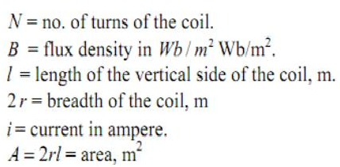](http://4.bp.blogspot.com/-X5879HEndAo/UgyQN6AZZWI/AAAAAAAAABo/yfU-J8ZqAyo/s1600/Untitled.png)

G = Constant.

Hence deflecting torque, Td α I.

**Expression for Controlling torque**

Since the instrument is spring controlled, Control torque = Cθ

Hence Tc α θ.

The pointer will come to a rest when Td = Tc

Therefore θ α  I

Thus the deflection is directly proportional to the operating current. Hence such instruments have a uniform scale.

**Range Extension of Ammeters and Voltmeters**

There is no fundamental difference in the operating principles of ammeters and voltmeters. Both are current operated devices (except electrostatic type voltmeters) i.e. deflecting torque is produced when current flows through their operating coils.

In an ammeter, the deflecting torque is produced by the current to be measured or by a definite fraction of it whereas in a voltmeter torque is produced by the current proportional to the voltage to be measured.

Thus, **the real difference between the two instruments is in the magnitude of the currents producing the deflecting torque.** The essential requirements of a measuring instrument are that its introduction into the circuit, where measurements are to be made, does not alter the circuit conditions and the power consumed by them for their operation is small.  
   
An [ammeter](https://en.wikipedia.org/wiki/Ammeter) is connected in series with the circuit whose current is to be measured. Therefore, it should have a low resistance. On the other hand, a voltmeter is connected in parallel with the circuit whose voltage is to be measured; therefore, it must have high resistance.

Thus we conclude that the difference is only in the resistance of the instrument, in fact, **an ammeter can be converted into voltmeter by connecting a high resistance in series with it.**

It is already seen that the [moving coil instruments](https://www.yourelectricalguide.com/2017/01/permanent-magnet-moving-coil.html) can carry the maximum current of about 50 mA safely and the potential drop across the [moving coil instrument](https://www.yourelectricalguide.com/2017/01/permanent-magnet-moving-coil.html) is about 50 mV. However, in practice, heavy currents and voltages are required to be measured. Therefore, it becomes necessary that the current and voltage being measured be reduced and brought within the range of the instrument.

**Range Extension of Ammeter by Shunt**

It is possible to extend the range of an ammeter by using a shunt. A shunt is a low-value resistance having minimum temperature co-efficient and is connected in parallel with the [ammeter](https://en.wikipedia.org/wiki/Ammeter) whose range is to be extended. The combination is connected in series with the circuit whose current is to be measured.

This shunt provides a bypath for extra current because it is connected across (i.e. in parallel with) the instrument. These shunted instruments can be used to measure currents many times greater than their normal full-scale deflection currents. The ratio of maximum current (with shunt) to the full-scale deflection current (without shunt) is known as the ‘multiplying power’ or ‘multiplying factor’ of the shunt.

**Emample**: A moving coil ammeter reading up to 1 ampere has a resistance of 0.02 ohm. How could this instrument be adopted to read current up to 100 amperes.  
   
**Solution**: In this case, Full-scale deflection current of the ammeter,   Im = 1 A Line current to be measured,    I  = 100 A Resistance of ammeter,             Rm = 0.02 ohm Let, the required shunt resistance = S

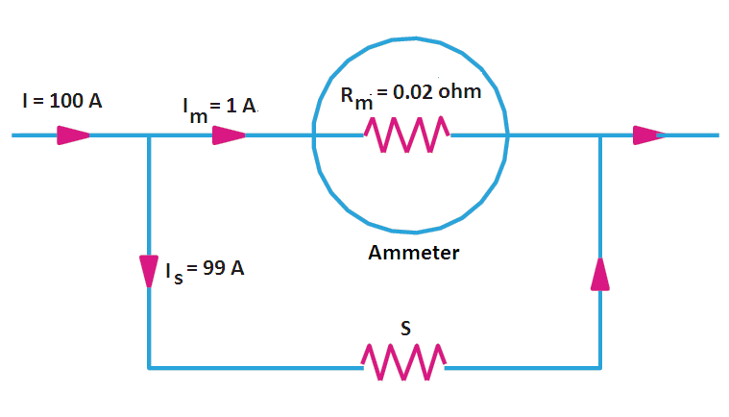

As seen from Figure, the voltage across the instrument coil and the shunt resistance is the same since both are joined in parallel.

∴  Im*Rm = S*Is = S(I − Im)

or  **S =  Im*Rm/(I – Im)** =  1*0.02/(100 – 1) = 0.02/99 =  0.000202

**Ans**.

**Range Extension of Voltmeter by Multipliers**

Multipliers are used for the **range extension of voltmeters**. The multiplier is a non-inductive high-value resistance connected in series with the instrument whose range is to be extended. The combination is connected across the circuit whose voltage is to be measured.  
   
**Example:** A moving coil voltmeter reading up to 20 mV has a resistance of 2 ohms. How this instrument can be adopted to read voltage up to 300 volts.

Solution: In this case Voltmeter resistance,             Rm = 2 ohm Full-scale  voltage of the voltmeter, ν = RmIm = 20 mV = 0.02 V Full-scale deflection current,            Im = v/Rm = 0.02/2 = 0.01 A Voltage to be measured. V = 300 V Let the series resistance required      = R

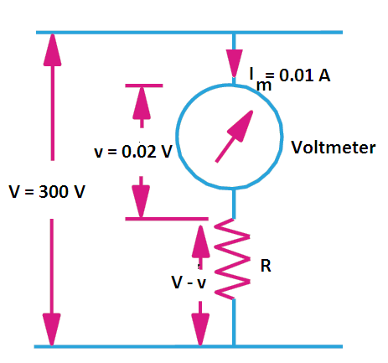

Then as seen from figure, the voltage drop across R is V – ν R *Im = V – ν or **R = (V – v)/Im**

or R = (300 – 0.02)/0.01 = 299.98/0.01 = 29998 ohms**Ans.**

Shunts can not be used to **extend the range of moving-iron AC ammeters** accurately. It is because the division of current between the operating coil and the shunt varies with frequency (since reactance of the coil depends upon frequency). In practice, the *range of moving-iron AC ammeters are extended by one of following methods:*